CA3: Group Project

**PhoneBoy**

Liam Cassidy – x15314866

Kevin Reid – x15513377

**The campaign**

Our chosen digital marketing campaign was to promote the release of a fictional mobile application which is designed to enable users to play GameBoy games on their smartphones and tablet devices. The concept of this campaign came from the both of us. We together hold a much appreciation for the GameBoy system and it’s games. So since there isn’t currently an official app to play these games, we decide to market this idea by making it out that Nintendo were releasing this as an app. The naming process went through a few revisions but we finally settled on the name PhoneBoy.

We want this campaign to evoke a certain type of emotion from people. When people see this it should give people a sense of nostalgia. People will remember a time when they had or played this system. Although our target market is not age restricted. While we are mainly focusing on the people who played the GameBoy when it was released, we also open to people who may not have been born when the GameBoy was around who maybe interested in playing the mobile application version of the system.

We decided to that the multimedia areas we should focus on would that we should design a flash advertisement, a website, an app and set up social media pages. Kevin handled the website, mobile application and the graphical design of both. Liam focused on the social media aspect of the campaign and creation the flash animation advertisement for PhoneBoy.

**Animation**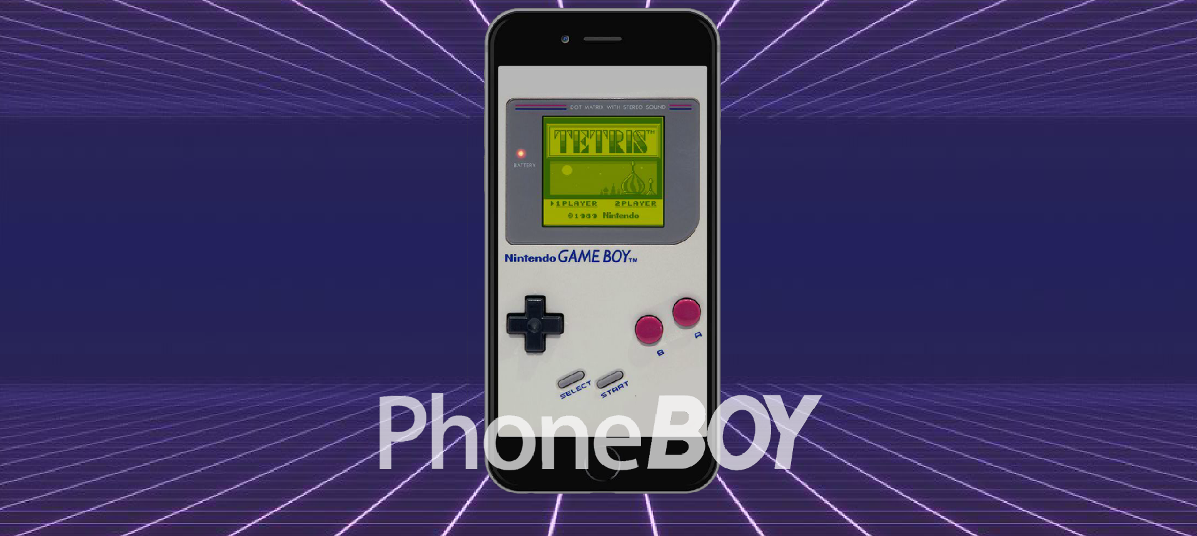

The flash animation was one of the first ideas that we came up for the marketing campaign. Using Adobe Flash, the animation was developed to display the impending release of the PhoneApp to the market. It is a short but effective flash animation which shows in great detail what on offer.

**Website**

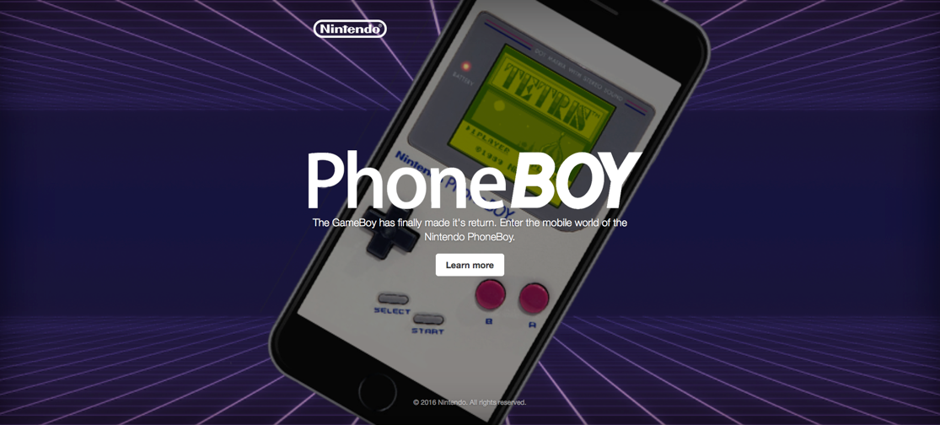

A website was created and designed to advertise the features that are present in the application for the PhoneBoy. The website was designed for both desktop and mobile users in mind. The website was effectively built by using Bootstrap, which displays a clean visual experience for both desktop and mobile users. The PhoneBoy website links the social media accounts for Facebook and Twitter. The website was published using the software CyberDuck.

It can be located on the internet under the URL <http://www.kevinreid.ie/phoneboy/>

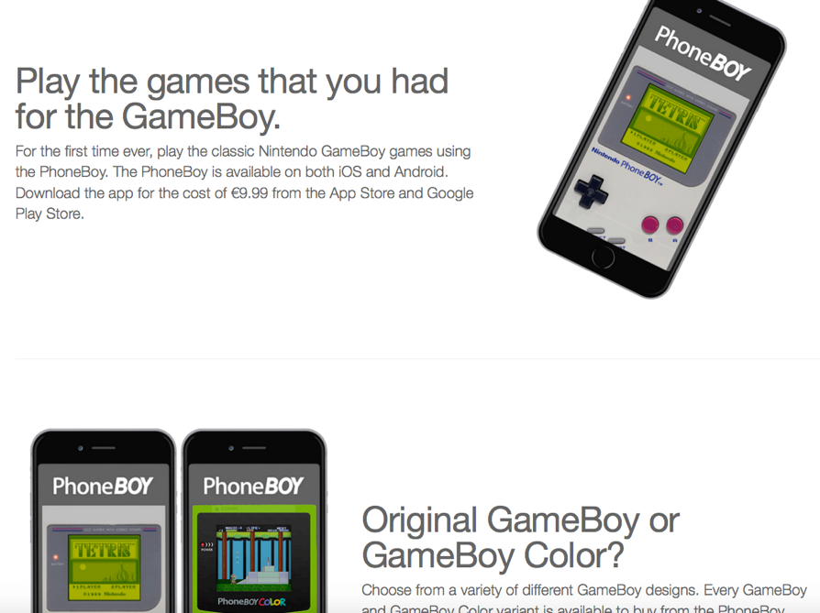

**Mobile App**

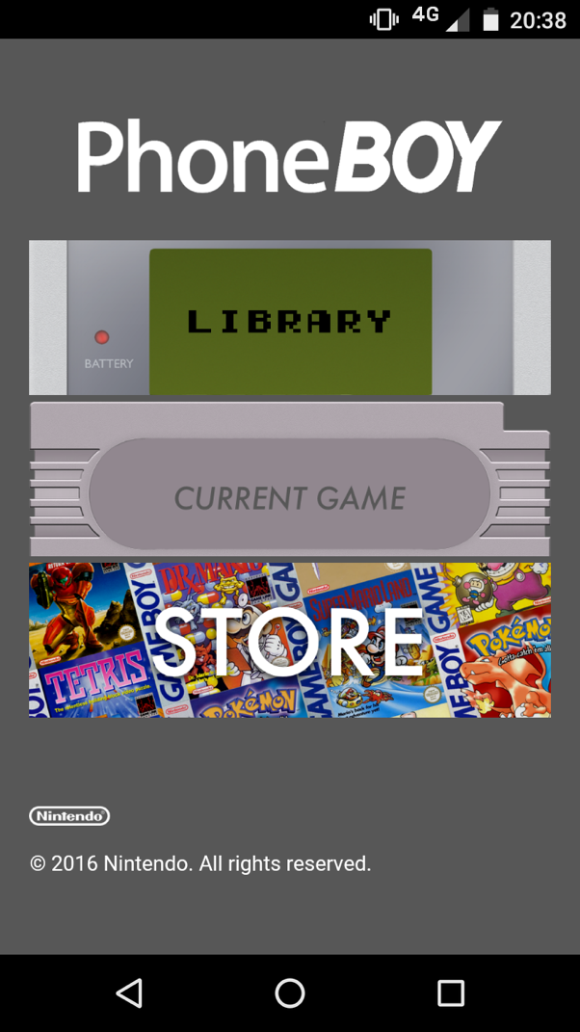

To showcase the ideas for the digital marketing campaign we decided to develop an mobile app. Deloped using HTML, the PhoneBoy displays the graphical interface of what the app is capable of doing. At the moment, the user has three options in the app. Play a game from the library, resume the game and purchase games and themes from the PhoneBoy store. The PhoneBoy app was published using PhoneGap. Include in the folder is both the HTML version of the application and a copy of the PhoneBoy apk for use with Android enabled devices.

It can be located on the internet under the URL <http://www.kevinreid.ie/phoneboyapp/>

**Social Media Integration**

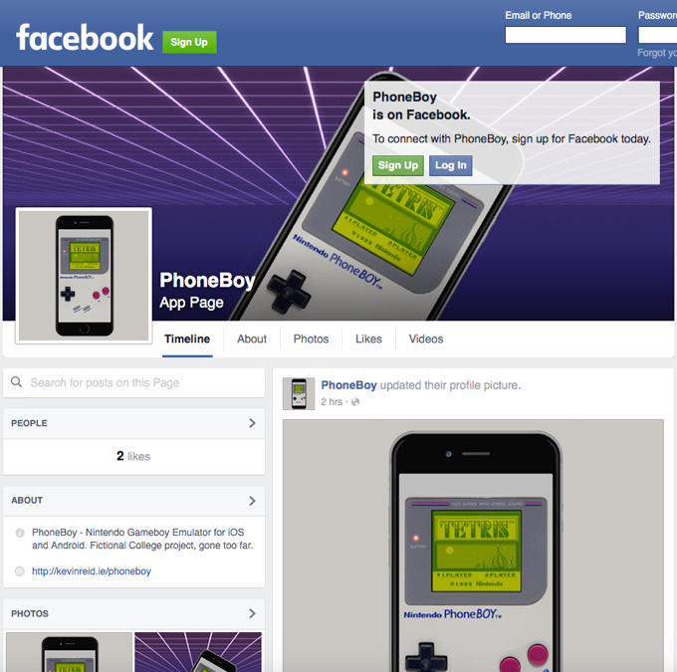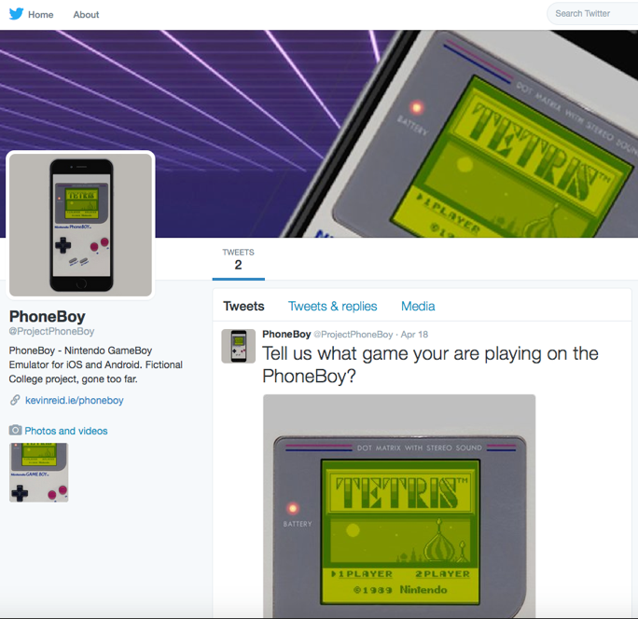

It was our goal to make this marketing campaign reach the biggest audiences, Facebook and Twitter have the majority of that audience. Both Facebook and Twitter have an ideal platform for marketing any product or business, so with that in mind we knew that we had to develop a following on both social media outlets. To entice users to like or follow the PhoneBoy page, we invite people to share with us their ideas, opinions and reactions to the PhoneBoy app. We like users to participate in polls and submit their screenshots of what games they are playing using the PhoneBoy app.

The social media accounts can be found on the PhoneBoy website under social media links or at:

<https://www.facebook.com/ProjectPhoneBoy>

<https://twitter.com/projectPhoneBoy>